Proper Dojo Etiquette

“A martial arts practice hall, a Dojo, is a place you go to practice being the best you can be.” M Gerber

- Shoes and socks are to be neatly placed by the wall, outside the Dojo
- Remove watches, bracelets, wristbands, etc.
- Enter (and leave) the Dojo with a deep Bow of respect and with the greeting “Oss!”
- Practice strength in humility, never bragging about accomplishments or rank
- When Shugo (‘Attention, Line Up!’) is called:
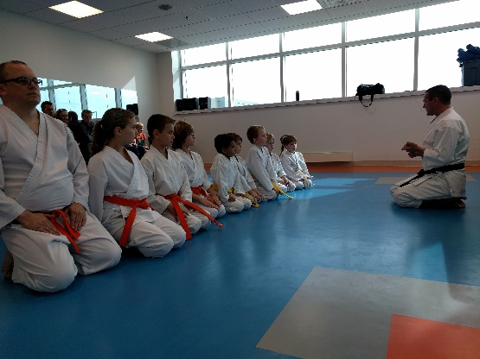
  - Talking stops
  - Hurry to your place in line
  - Maintain good posture
- When Seiza (Kneel) is called:
  - Kneel quietly
  - Eyes front
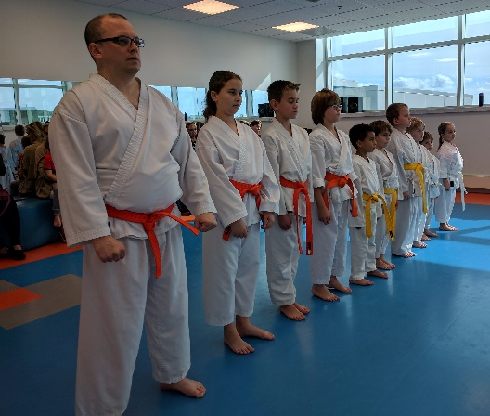
  - Maintain good posture
- During class:
  - Respect all people
  - Listen intently to Sensei and Senpai
  - Stay focused
  - Train like a warrior
  - Enjoy your training

Remember, your Dojo is a place where you are an important part of a team. It is your place to become stronger in Body, Mind and Spirit – Respect it and Enjoy it!

